|  |  |  |  |  |  |
| --- | --- | --- | --- | --- | --- |
| Date | December 13, 2022 | | | Tester Name | Syed Shahabuddin |
| Environment | Penfax - Test | | | Login used |  |
| Operating System | Windows | Version: | Update: | | |
| Software Used | Edge | Version: | Update: | | |
| Select Software | Version: | Update: | | |
| Release version | 22.4.1 | | | | |
| Title | E23.05 | | | | |
| Test Type | Regression | | | | |
| Test Scenario | Process Daily Payment Production Batch | | | | |
|  |  | | | | |
| Expected Results | Must have investment transactions processed on Penfax. Set up the following transactions to verify them later on in the test case:  - Withdrawal through DC Benefit Selection  - Withdrawal through Investments  - SRB  - Also enter a payment that should fail out in the PIT batch  Test Case Description:   * + Using the daily batch process schedule, let the PIT batch and following payment batches run as they would in a normal scenario   + Verify that the batch ran successfully   + Verify that for the member's found in Step 1's precondition, the payments were processed successfully and correctly   + Verify that the payments were actually processed   + Verify that each payment has the appropriate taxes displayed within payment production   + Verify that any validations are actually correct   + Verify that payments are properly separated by Benefit payment vs Vendor payment   + Verify that all cheques being issued are reported under "Cheques" * Verify that the Cheque Extract report is generated | | | | |
| Pass/Fail | Pass | | | JIRA# | N/A |

PIT failed a few times already in testing, not testing the Payment production adhoc batch re-run at this time.

|  |  |  |  |
| --- | --- | --- | --- |
| Stakeholder | Type of payment | Retire/term (over 50/under) | Batch and letters successful |
| 258661 | Cash | Term |  |
| 302728 | LIRA (2 FI’s) | Retire |  |
| 258669 | Cash (partial) | Retire |  |
| 280602 | RRSP | Term |  |
| 128467 | SRB to spouse | SRB (added SIN & address to spouse) |  |
| 341242 (299191) | Death to spouse (cash) | Spouse USA resident (added SIN) |  |
| 253278 | Vpb lump sum | VPB NET pmt |  |
| 258664 | VPB to outside annuity | 200k gross |  |
| 286915 | Excess to ER (through investments) | confirm ministry of finance cheque payee |  |

All payments show up under the benefit payments under payment production:

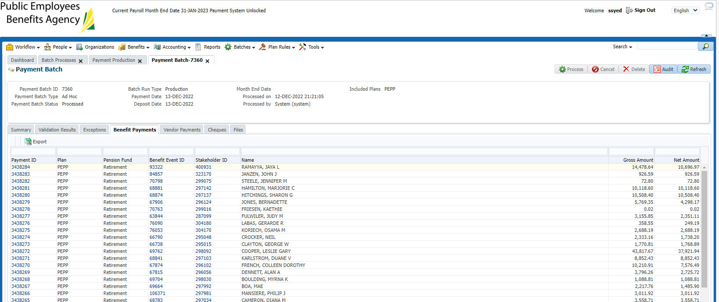

Non-resident and lump sum tax looks reasonable

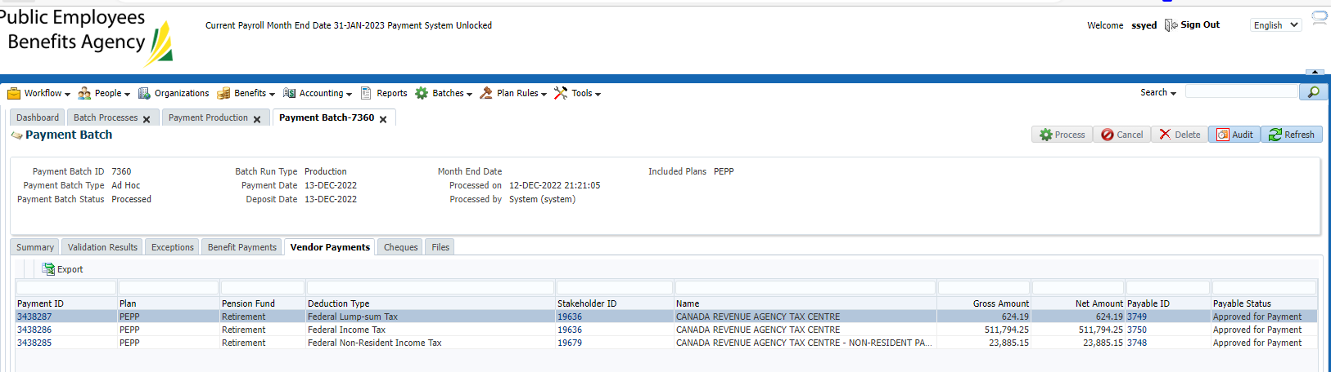

List of cheques are correct including override the payee name & include all above payments

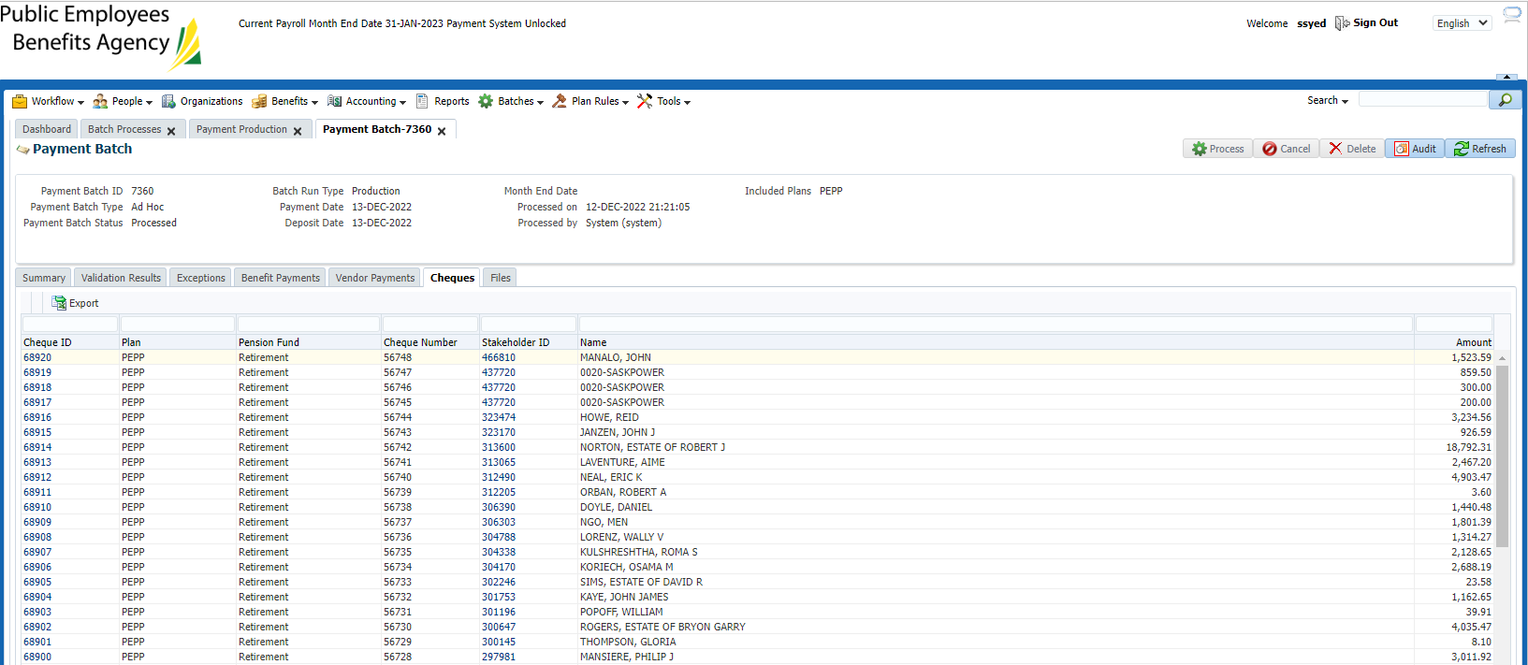

EFT report complete:

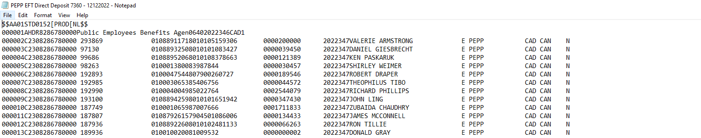

Cheque csv file looks correct & includes all payments:

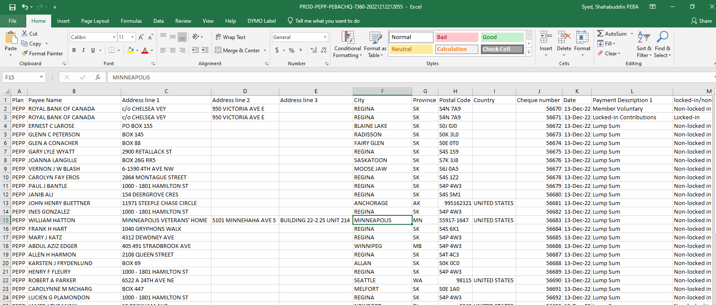

No tax deducted from any of the payment to FI’s

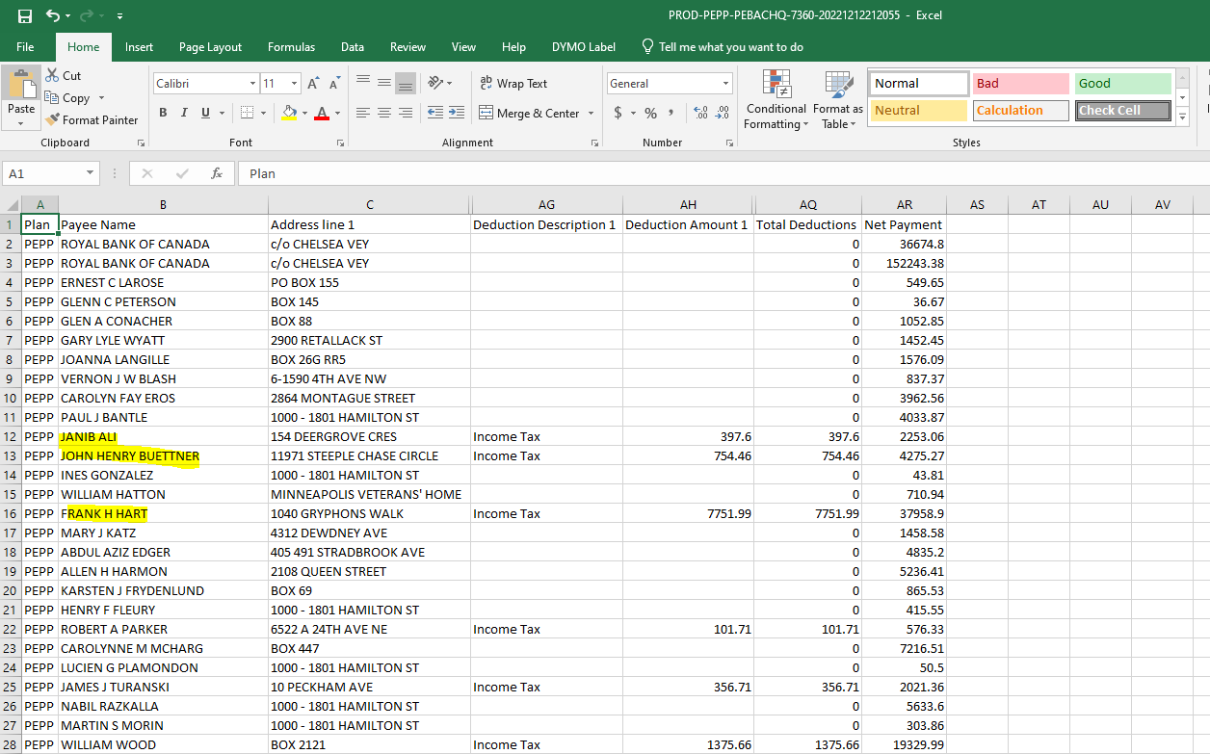

Daily payment report generates & includes all pages/payments:

